
The Lion's Cocoon
Welcome guide

🗺️ Access map
GPS coordinates: 47.637868° N, 6.864052° E
The cul-de-sac is a very short, discreet street in a heritage area. It is located in the old town of Belfort, close to monuments such as Saint-Christophe Cathedral and Place de l'Arsenal, making it easy to find.
In the immediate neighbourhood: local shops, old town, historic monuments, municipal police station and tourist office..

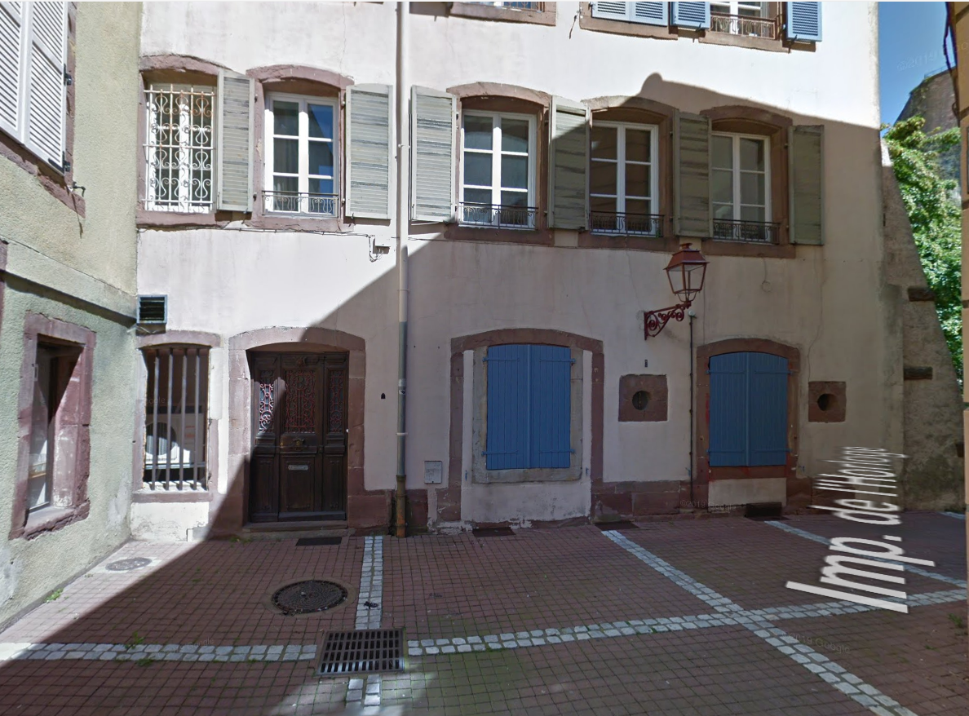

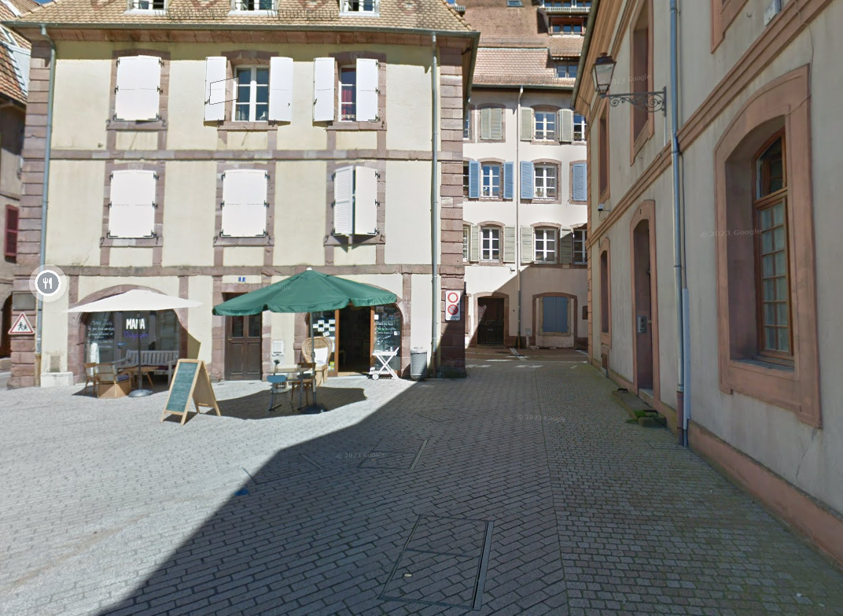
Car parks nearby (all within walking distance)
Arsenal car park – approx. 200 m below the Lion of the Citadel (paid parking)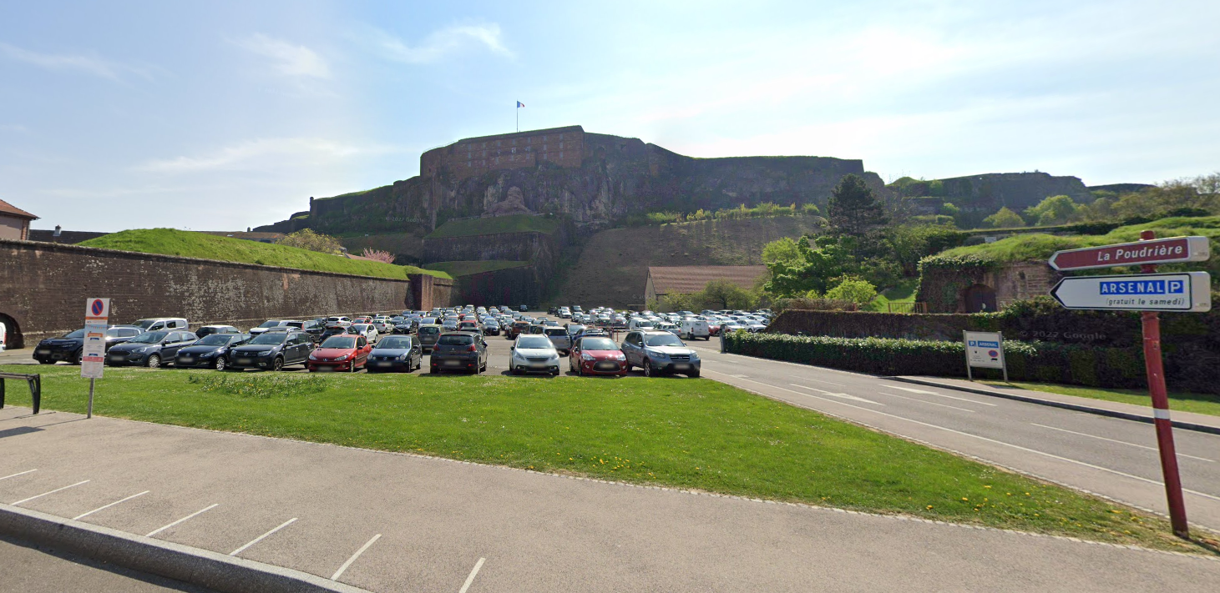

G. Pompidou car park near the National Police station – approx. 220 m away (paid parking)
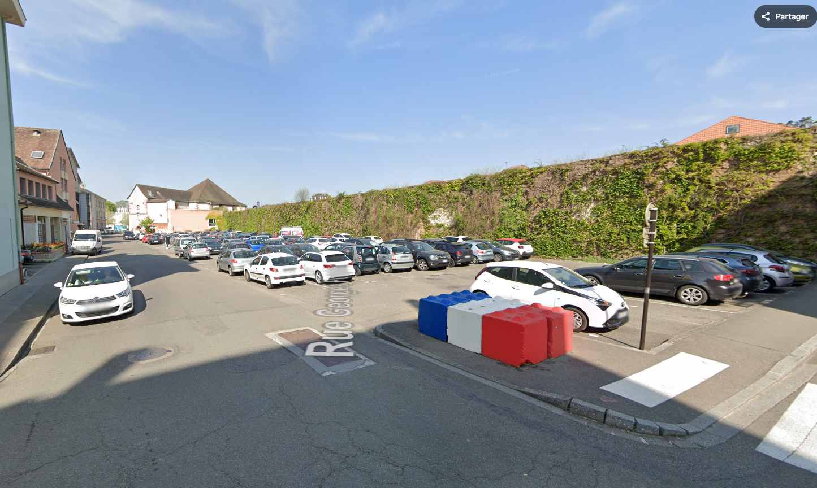

Car park located beneath the citadel Allée du Souvenir Français (free of charge)
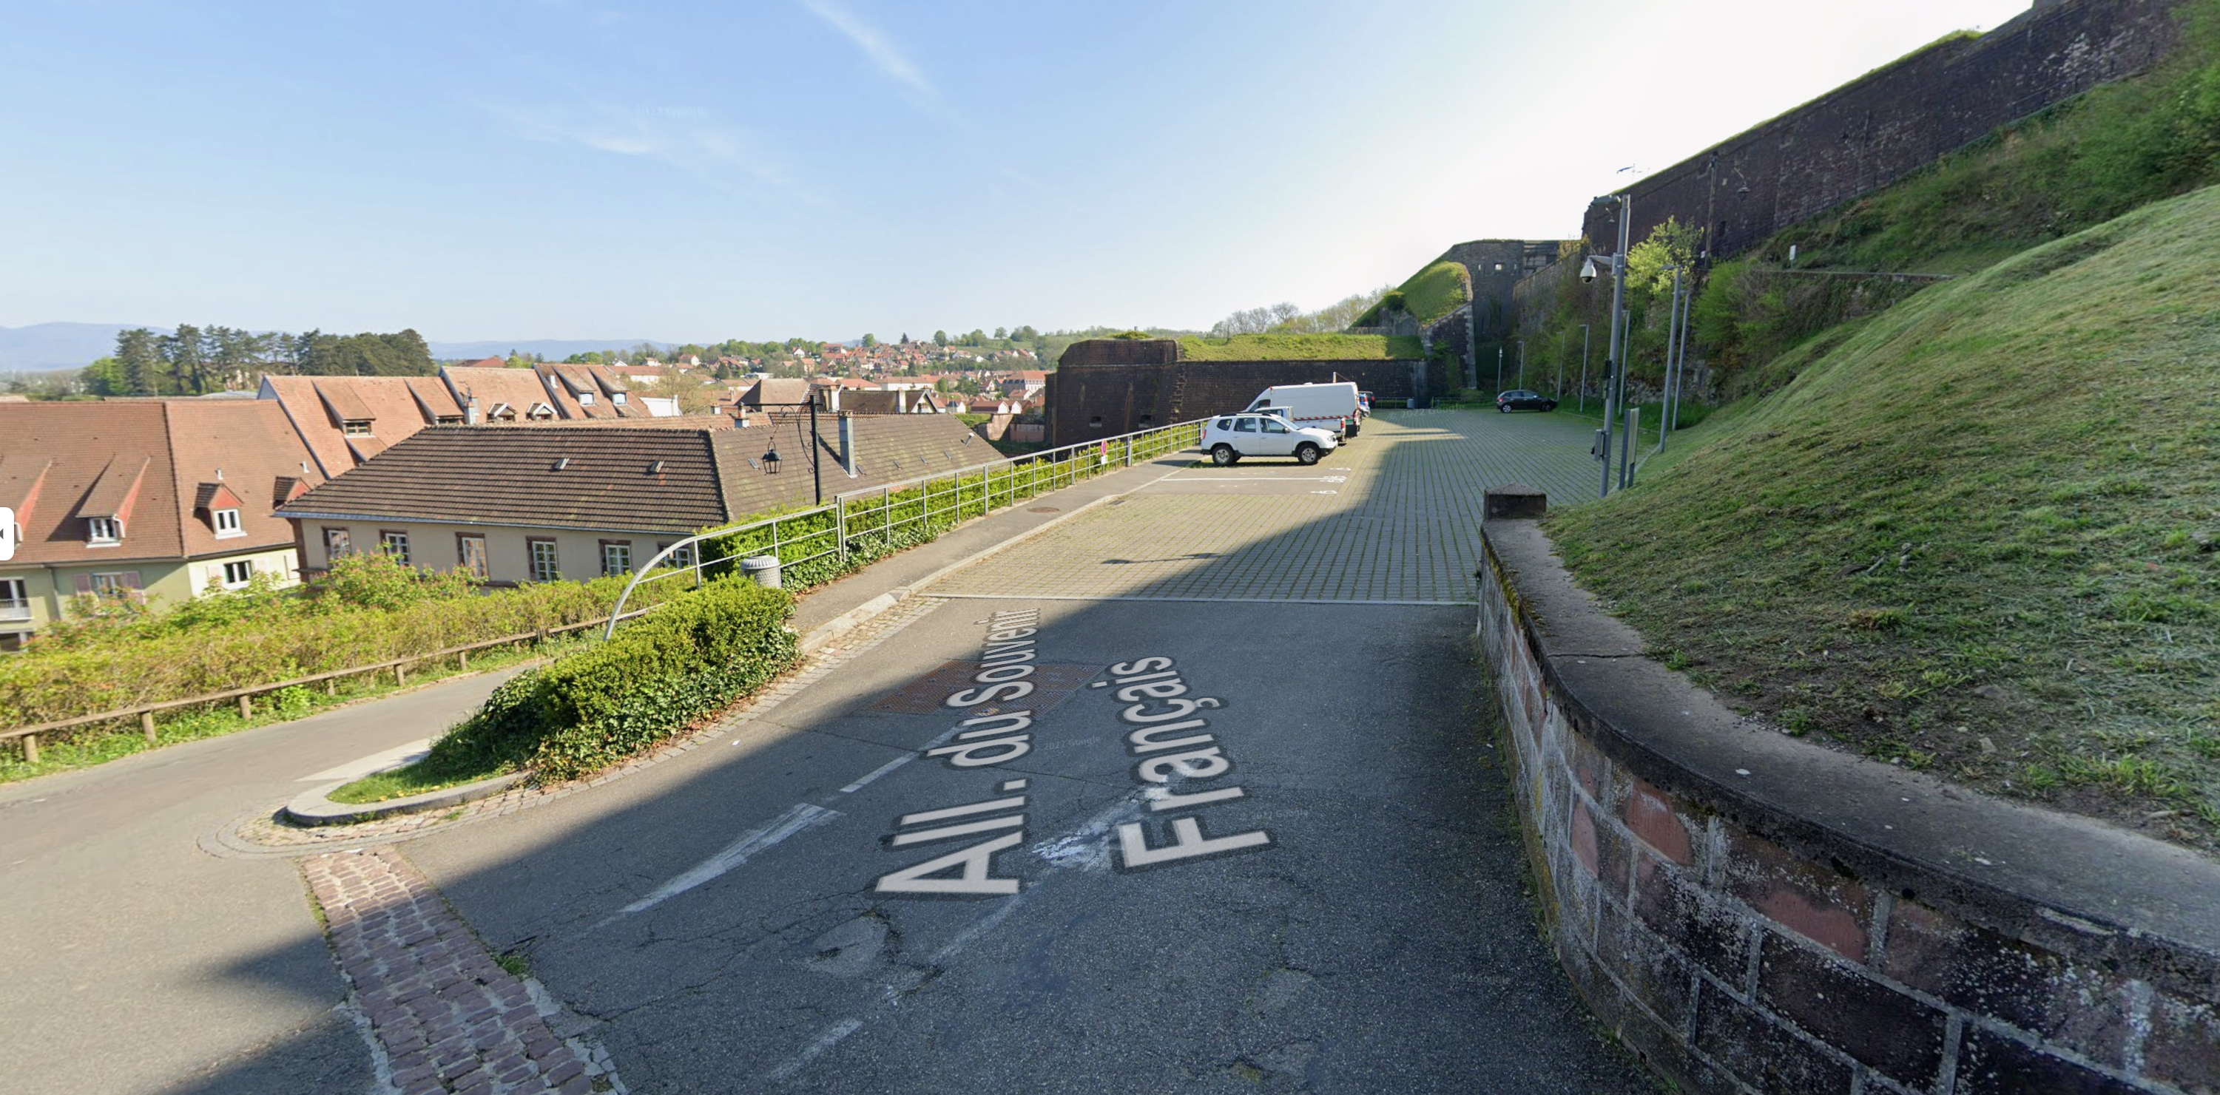

Motorcycle parking In front of the Tourist Office, a few dozen metres from the flat
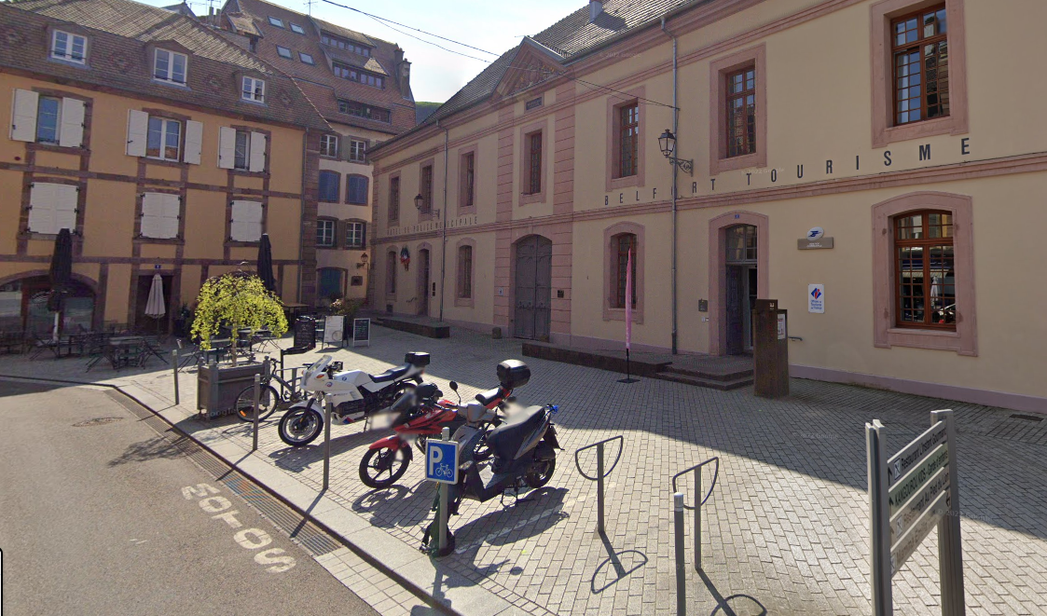

🚶 Access on foot from Belfort station

Distance: ~1.3 km (15–18 minutes)
Recommended route:
Exit the station on the town centre side (on the left).
Walk up towards Faubourg de France (pedestrian street) to Place Corbis.
Cross La Savoureuse straight ahead and continue to Place d'Armes.
Follow the signs for Saint Christophe Cathedral → Impasse de l'Horloge is on the right-hand side of the square (next to the tourist office).

🕒 Arrival and departure
The flat has a private entrance.
Arrival:
• Check-in time: from 3 p.m.
• Key collection from the key box: a code will be generated for you on the day of arrival.

Departure:
Check-out time: before 11 a.m.
Before you leave, please:
• Turn off the lights.
• Close the windows.
• Take out the rubbish.
• Put sheets, pillowcases, towels and shower mats in the laundry bag.

📶 Wi-Fi connection
Network name (SSID): LiveBox 7F90
Password: pXFI U6RX ie3Y 2KwF Xy

🧭 Useful information
Please note that the front door does not have an outside handle, so do not leave the apartment without your keys.
🏡 House rules
Non-smoking accommodation.
No parties.
Please respect the neighbors.
Please keep quiet between 10 PM and 8 AM.
Please leave the apartment tidy and the dishes clean.
Sleeping capacity: 2 people and, if needed, 1 extra bed.
A high chair and a travel cot for babies are available upon request.

 Available equipment
- Fully equipped kitchen
- Bed linen and towels provided
- Central gas heating
- Washing machine (instructions included)
- Basic cleaning supplies
- Dishwasher
- Salad spinner
- Oven
- Microwave
- Hair dryer
- Television with fiber optic internet
- Luggage rack
- Electric kettle
- Toaster
- Raclette grill
- Crepe makers
- Vacuum cleaner
- Iron and ironing board
- Games chest

 Important emergency numbers
SAMU (Emergency Medical Service): 15
Police: 17
Fire Department: 18
European Emergency Number: 112
Deaf/Hard of Hearing Number: 114
Saint Christophe Pharmacy: 1 rue de l’église, Place d’Armes, 2 minutes walk, next to the cathedral.

 Local shops
Near the apartment:
L. François Pastry Shop, Place d’Armes, 90000 Belfort
Perello Grocery Store – Le Grain de Café – 6 Place d’Armes, 90000 Belfort
Les Marronniers Café Bar – 8 Place d’Armes, 90000 Belfort
Le Trois – 3 Place d’Armes, 90000 Belfort
Au Tabac Epicerie du Lion – 6 Place d’Armes, 90000 Belfort
Le Bar à Vins du Lion – 2 Place d’Armes, 90000 Belfort
Les Marronniers Café Bar – 8 Place d’Armes, 90000 Belfort
Restaurant de la Place – 13 Rue du Quai, 90000 Belfort

Towards the pedestrian street:
Bistrot des Moines – 22 Rue P Dreyfus Schmidt, 90000 Belfort
Finnegan's - 6 Bd Carnot, 90000 Belfort
Supermarket: MONOPRIX: 1 avenue du Maréchal Foch, 90000 Belfort

📷 Housing Gallery
Photo Entrance / Exterior
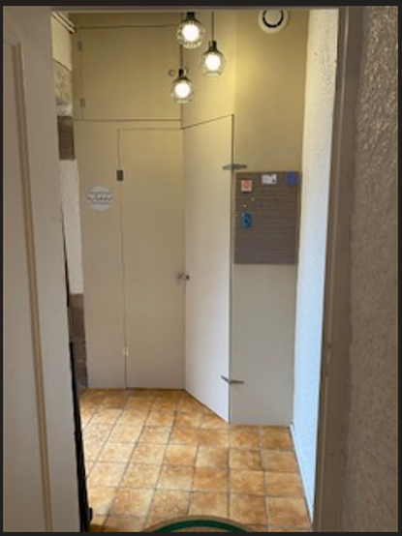

Living room photo
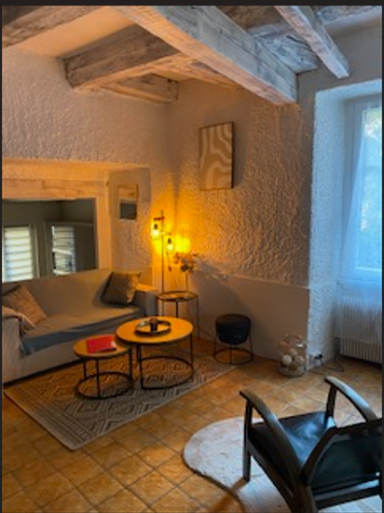
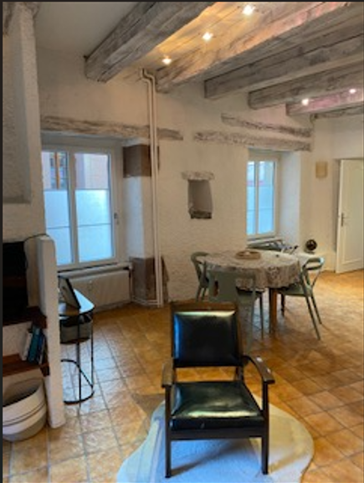

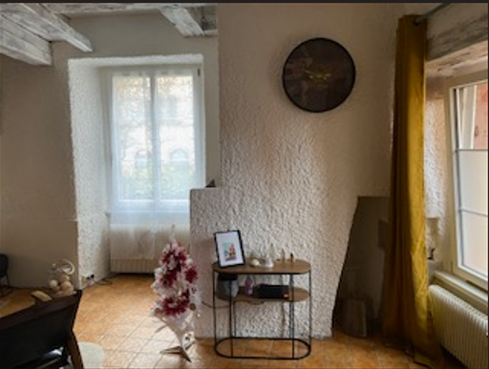

Bedroom Photo
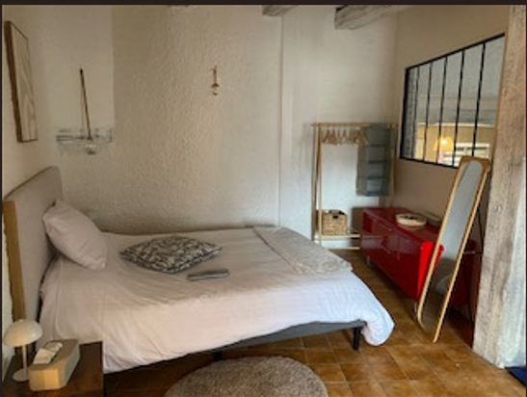

Kitchen photo
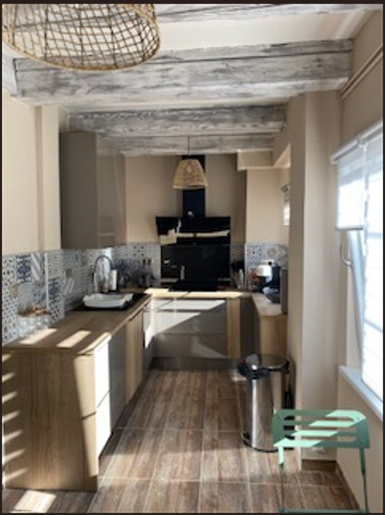
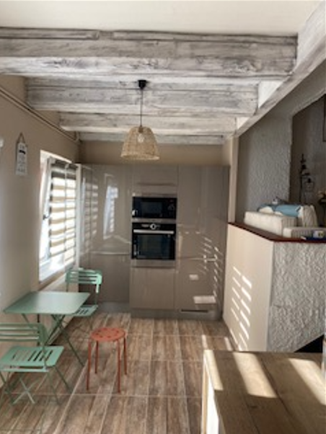
Bathroom Photo
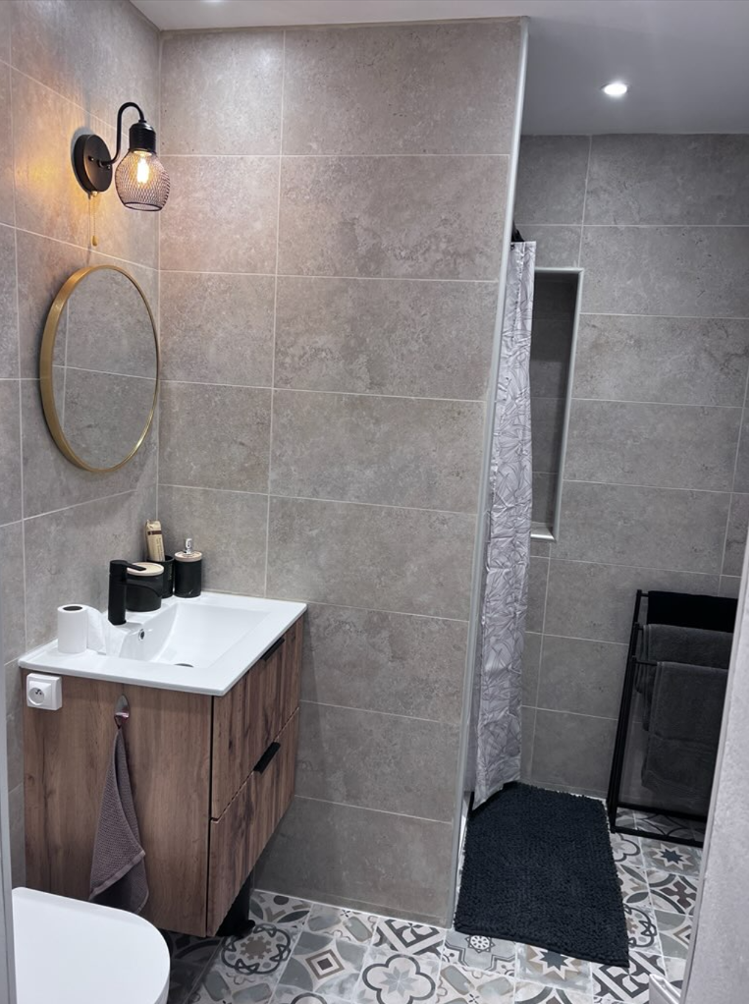
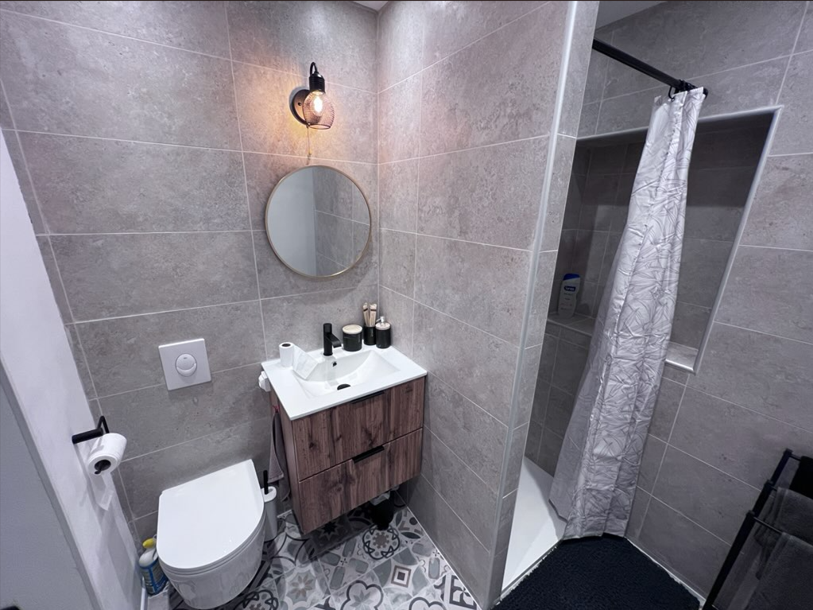

Final remarks
Thank you for choosing our apartment. If you have any questions during your stay, please contact us.
Enjoy your stay in Belfort!
ANNE & OLIVIER

🔥Fire Safety Instructions🔥

🚨 1. In case of fire
- Stay calm.
- Call the emergency services: Fire Department 18, European emergency number 112.
- Warn other occupants and evacuate immediately.
- If the smoke is thick, crawl on the floor.
- Close doors behind you to limit the spread of fire.

🔥 2. Using fire-fighting equipment
- Use the fire extinguisher only if the fire is small and controllable.
- Never remove or disable the smoke detector.

🏃 3. Evacuation
- Identify the evacuation route as soon as you arrive.
- Do not retrieve personal belongings.
- Go to a safe assembly point and wait for emergency services.

⚡ 4. Prevention
- Never leave the kitchen or a candle unattended.
- Unplug unused appliances.

🧯 5. In case of smoke in the home
- Place a damp cloth over your mouth.
- If the door is hot, do not open it.
- Stay in the safest room and signal your presence at the window.

🧯 6. Emergency numbers
- Ambulance (SAMU): 15
- Police: 17
- Fire Department: 18
- European emergency number: 112
- Helpline for the deaf/hard of hearing: 114

